**Name: JOMOL R.K**

**Roll No:09**

**Batch:S2MCA**

**Date:06/05/2022**

**ADVANCED DATABASE MANAGEMENT SYSTEM LAB**

**Experiment No.: 7**

#### AIM

**To familiarize with Group by and Having clause**

# **Question**

1.List the branches having sum of deposit more than 5000.

2.List the branches having sum of deposit more than 500 and located in city BOMBAY

3.List the names of customers having deposited in the branches where the average deposit is

more than 5000.

4.List the names of customers having maximum deposit

5.List the name of branch having highest number of depositors?

6.Count the number of depositors living in NAGPUR.

7.Give names of customers in VRCE branch having more deposit than any other customer in

same branch

8.Give the names of branch where number of depositors is more than 5

9.Give the names of cities in which the maximum number of branches are located

10.Count the number of customers living in the city where branch is located

**Output**

1.List the branches having sum of deposit more than 5000.

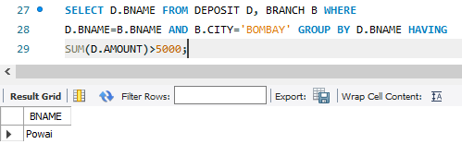

2.List the branches having sum of deposit more than 500 and located in city BOMBAY

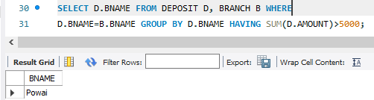

3.List the names of customers having deposited in the branches where the average deposit is

more than 5000.

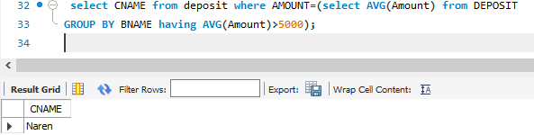

4.List the names of customers having maximum deposit

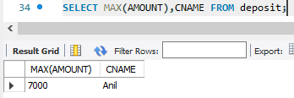

5.List the name of branch having highest number of depositors?

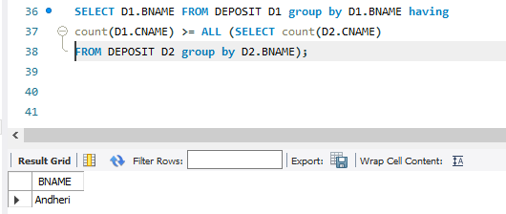

6.Count the number of depositors living in NAGPUR.

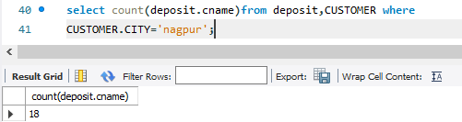

7.Give names of customers in VRCE branch having more deposit than any other customer in

same branch

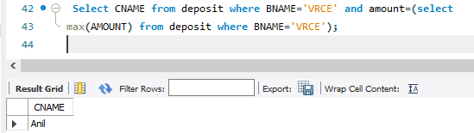

8.Give the names of branch where number of depositors is more than 5

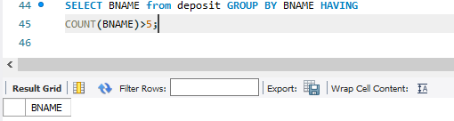

9.Give the names of cities in which the maximum number of branches are located

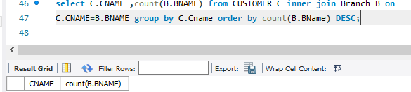

10.Count the number of customers living in the city where branch is located

